**JUNGLE ADVENTURE**

Software Requirements Specification

*SRS_Doc_Jungle-Adventure_TeamAvenger_Fall 2018*

September 23rd, 2018

**Team Avengers**

*Aaleyah Joseph, Adefemi Kolawole, Matteo Quintero, Scott Nguyen*

AJ: GREEN & AK: BLUE & MQ: YELLOW & SN: RED

Table of Contents

1 Introduction 4

1.1 Problem Statement 4

1.2 Purpose 4

1.3 Scope 4

1.4 Definitions, Acronyms, and Abbreviations (Table1- Definitions) 4

1.5 References 6

1.6 Overview 6

2 Overall Description 7

2.1 Product Perspective 7

2.2 Product Functions 7

2.3 User Characteristics 7

2.4 Constraints 7

2.5 Assumptions and Dependencies 7

2.6 Apportioning of Requirements 7

3 Specific Game Requirements 8

3.1 Overall Game Description 8

3.2 Setting 8

3.2.1 Game Map 9

3.2.2 Game Rooms 9

3.2.3 Monsters 16

3.2.4 Puzzles 17

3.2.5 Artifacts/Crafting 19

3.2.6 User Interfaces 22

3.2.7 Artifact Table 23

Use Case Diagram 23

3.2.8 Monster Features 25

Use Case Diagram 25

Purpose 25

Associated Functional Requirements 25

3.2.9 Puzzle Features 26

Use Case Diagram 26

Purpose 26

Associated Functional Requirements 26

3.2.10 Artifact Features 27

3.2.11 Inventory Features 27

Use Case Diagram 27

Purpose 27

Associated Functional Requirements 27

3.2.12 Item Features 28

Use Case Diagram 28

Buy Sell Trade 28

Purpose 28

Associated Functional Requirements 28

3.2.13 Command Menu 29

Open inventory 29

Purpose 30

Associated Functional Requirements 30

3.3 Software System Attributes 30

3.3.1 Reliability 30

3.3.2 Availability 30

3.3.3 Usability 30

3.4 Other Requirements 31

This Page is intentionally leave blank.

(Section break: don’t delete)

# Introduction

This is a Software requirement specification for a text-based adventure game “Jungle Adventure.” It is meant to aid the developing team handling this project with directions and instructions needed to successfully build the game according to expected features.

## Problem Statement

“A crime has just occurred, several people are injured, and some are dead. You (the player) are lucky to be alive, but your spouse has been captured and the assailants have escaped before the rescue team got to the scene. You are determined to rescue your spouse at all cost. To get to your spouse safely, you must make several choices, solve several puzzles, endure/sustain several injuries, use several weapons, and conquer several enemies. The choices you make can be for or against you on this mission to rescue your wife.”

## Purpose

The purpose of this document is to give directions to the developing team on how to develop the interface, and also the implementation of the algorithm and logic required for smooth transition in the game.

## Scope

To ensure this system is created in a timely manner and according to class requirements, this game will comprise of 30 different rooms, 11 reusable artifacts, 8 reusable puzzles, and 8 reusable monsters. Each room has an entry and exit points which also serves as the linkage points to other rooms, every room must link to at least two others. There will be a short textual description for each room (graphics would be even better), and a hint or description of any monster, artifact, and puzzles available in each room by default will also be displayed.

The player will have the option to call for/purchase available artifact, exit a current room, enter a room, pause the mission, and continue with a mission.

Because player can lose or gain points as they proceed in the game, the page will display the current number of points the player has. Accumulated points can be used to purchase artifacts as needed. Also, by clicking a special appointed key, the player can see the artifacts and resources available for purchase in each room.

The last item for display is the state of player’s health score. The player must be warned when their health state / point is very poor. Player automatically dies when health is below 5 %.

## Definitions, Acronyms, and Abbreviations (Table1- Definitions)

|  |  |
| --- | --- |
| Term/Acronym | Definition |
| Player | Someone who plays the text-based adventure game on a computer. |
| Monster | An enemy that hinders the player from proceeding in his/her adventure |
| Puzzle (PZ) | A riddle, question that the player is required to solve on his journey |
| Item | An entity that the player can benefit from. It can be in form of food or water for strength. It can also be I the informed of artifact or ammunition for player to fight the monsters |
| Inventory | A compilation of all items available for player to use or purchase when needed. |
| Artifact | Items that can be purchased or used by player on his journey. It can be food or water, It can also be ammunition to fight against his attackers. |
| Room (RM) | There are 30 rooms in total in the game. The player can move from one to the other. |
| Tiger (TIG01) | An attacker that is designated to hinder the player as he journeys through the game. |
| Scorpion (SCR93) | An attacker that is designated to hinder the player as he journeys through the game. |
| Cheetah (CHE87) | An attacker that is designated to hinder the player as he journeys through the game. |
| Snake (SNK78) | An attacker that is designated to hinder the player as he journeys through the game. |
| Homo-habilis (HOM32) | An attacker that is designated to hinder the player as he journeys through the game. |
| Homo-erectus (ERE31) | An attacker that is designated to hinder the player as he journeys through the game. |
| Tim King of the Jungle (TIM76) | An attacker that is designated to hinder the player as he journeys through the game. |
| Jack the Overlord (JAC23) | An attacker that is designated to hinder the player as he journeys through the game. |
| Soldier (SOD04) | An artifact that can be of help to the player in his/her adventure |
| Knife (CUT89) | An artifact and a protective device for the player. |
| Water (H2O82) | A drinkable substance to replenish the strength of player |
| Pistol (GUN78) | A short gun, an artifact the player can use against monsters |
| Band aid (BA448) | An artifact the plater can use in case of wounds and cuts |
| Blanket (BLKT77) | An artifact the player can use for protection from bee’s attack |
| Umbrella (UMB44) | An artifact the player can use to prevent sun, wind, or rainfall attack. |
| **Jungle tools  (JGTL99) | An artifact for fighting. Can be either of a wooden Spear, or a bows and arrow |
| Stone (ST45) | An artifact the player can use to fight the muster. |
| Wood/Log (WLG18) | An artifact the player can use to fight the muster. |
| Warrior (WAR784) | An artifact the player can use while travelling through the rooms. He has more potential to help than other artifacts. |
| Antidote Potion (POR78) | An artifact the player can use against poison from snake or scorpion’s bite. |
| ID: Identification Number | A unique identifier for the person or item/subject it references |
| DESC: Description | A textual explanation of the name or purpose of the item/subject it references |
| DEP: Dependency | An item, subject, or feature that mandatorily influences the item it references |

## References

There are no external references for this document.

## Overview

This document is divided into three main section: Introduction, Overall description, and Specific Game Requirement. The introduction gives the general overview and purpose of the document itself, it also entails the definition of abbreviation and terms used throughout the document. The overall description explains the perspectives, functions, characteristics, constraints, and dependencies needed for complete and successful implementation of the game. The specific game requirement discusses the major elements that make up the game itself. They are the monsters, items, inventory, puzzles, and rooms. Each of these elements has their own specific IDS, description, and necessary dependencies. This section also features the use case diagram for each element in the game.

# Overall Description

This section will explain the system interactions that occur in the game.

## Product Perspective

This game is a part of requirement for ITEC 3860 (Software Development 1) for Fall Semester 2018

## Product Functions

The game must allow the player to navigate through its thirty (30) rooms from one to another

Also, it must also allow the player to pick up items and drop items during the course of the game. When items are added, the game must allow player’s inventory to grow, and also shrink whenever items are dropped.

In addition, the game must allow attack and fight, dodge and flight between players and the monsters in the game. When a player defeats a monster, his health-points should increase, else his health-points decreases. The game must also allow the player to leave a room if the monster in such a room becomes too difficult to conquer.

Finally, the game must allow the player to encounter and solve puzzles in the course of his/her adventure. The game will require the player to enter the response to each encountered quiz in the form of a string in the textbox interface provided.

## User Characteristics

This game is meant to be played by anyone between the age of 15 and older.

## Constraints

* The game needs to have a reliable user interface for user to navigate through.
* There are no safety and security considerations regulatory policies
* This game can only run on desktop-based devices. Hence, the game cannot run on mobile or touch device.

## Assumptions and Dependencies

Not applicable

## Apportioning of Requirements

Not applicable

# Specific Game Requirements

This section describes in sufficient details all elements needed for successful design of all elements (rooms, monsters, items, inventory, and puzzles) required for a successful build of the game.

## Overall Game Description

The game is a about a player who embarks on a rescue mission, his main task is to rescue his/her spouse who was captured and taken into in a thick forest by some criminals who invaded their village of residence. The player needs to locate the criminals/assailants/kidnappers as fast as possible to save his wife, needs to confront creatures that live in the jungle, needs to call / order artifacts as needed, needs to correctly solve puzzles to progress on this mission— all puzzles answered correctly gives the player points which can be later used to purchase artifacts.

Because the mission is set in a jungle, the player will encounter several wild creatures. The more the player defeats them, the more points gained. The more points accumulated, the more artifacts he/she can later purchase as needed for the mission.

## Setting

All events occurred in a rural setting. The criminals / kidnappers ran into a thick forest (jungle) with the player’s spouse. Unknown to them, they left a path that leads back to them. The jungle has several wild animals and other dangerous entities the player must confront.  These creatures constitute monsters in this game

### Game Map

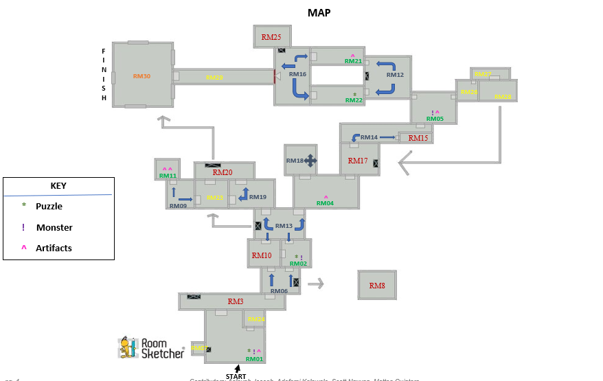

### Game Rooms

|  |  |  |  |  |  |  |  |
| --- | --- | --- | --- | --- | --- | --- | --- |
| Room Name | Room ID | Monsters  Included | Artifact  Included | Puzzle  Included | Description | Value / Worth | Pathways |
| Jungle Furry | RM01 | Homo habilis (HOM32)(added it to different room | BA448 | PZ02 | You have entered the Jungle to go after your spouse! There is a trail of blood that leads to a clue/puzzle that the kidnappers or your spouse seemed to have dropped (PZ02). There is another room to the left, slightly to the right and exit straight ahead. Player must fight and defeat Homo habilis (HOM32) to exit room. | Solving the puzzle and defeating the monster will fetch player 10 points each totaling to 20 points | RM07  RM24  RM03 |
| The Snake Keeper | RM02 | Snake(SNK78) | N/A | PZ09 | Solve puzzle (PZ09) to enter room. As soon as you enter the room a snake (SNK78) has attacked you. Once you have defeated the snake you can exit straight ahead or to the left. | Solving the puzzle and defeating the monster will fetch player 10 points each totaling to 20 points | RM10  RM13  RM06 |
| Lake Finder | RM03 | N/A | Water  (H2O82) | PZ05 | Contain clean water of life helping the player to keep them alive by drinking it to heal life points, store it for later to heal, or clean tools. | Heal Health  And solving the puzzle gives you 10 points | A secret pathway opens to RM09 if you solve a puzzle  RM06 |
| The Tree of Faith | RM04 | N/A | Wood/Log (WLG18) | N/A | Your health has decreased, and you are hungry. There is a tree with some unknown fruits; you will do anything for survival. You spotted a wood/log (WLG18) that will be able to help you get the fruit out of the tree. There is an exit to the left or right up ahead. | Getting the fruit out of the tree will increase the player health by 15. | RM18  RM13  RM17 |
| Land of the Tiger | RM05 | Tiger (TIG01) | Band-Aid (BA448) | N/A | You see footprints that lead you to RM05 when you enter there is a monster (TIG01) with an exit to the left or right. | Defeating the monster will give the player 20 points. | RM14  RM26  RM12 |
|  |  |  |  |  |  |  |  |
| Swampy ditch | RM06 | N/A | N/A | PZ01 | A ditch is beside player’s pathway. Player must solve 2 puzzles to move ahead. You can also exit the room if the puzzle are too hard to answer. | Solving both puzzles will fetch player 10 points in total towards other needed artifact. 10 point for each puzzle. | RM03  RM02  RM10  A secret pathway opens if you solve a puzzle |
| Treasure room | RM07 | N/A | Knife(CUT89) | N/A | An empty room with just a golden treasure chest | A Knife | RM01 |
| Trap Room | RM08 | N/A | N/A | PZ08 | Trap floor that will break down and fall to death. | GAME OVER | YOU DIE |
| Bees Highland | RM09 | N/A | Blanket  (BLKT77) | N/A | This room houses a lot of bees. The player needs to take caution. He also needs to purchase blanket before going into the room, to avoid being bitten. The blanket is the only protection available. Hence, he must have enough points to purchase one. | Blanket requires 20 points to purchase | RM23  RM11 |
| Marsh pit | RM10 | Scorpion  (SCR93) | Antidote Potion  (POR78) | PZ10 | A pit fall trap full of scorpion must solve the puzzle to get out or a given a chance to kill a scorpion it drop antidote potion. | The puzzle solve matching picture to open the door to escape. If stun player loses 5 health points. | RM02  RM13  RM06 |
| The Path Less Traveled | RM11 | N/A | Stone (ST45)  Pistol (GUN78) | N/A | As you enter the room there are two artifacts (ST45 & GUN78). There is an exit to left and right. | ST45 has a value of 2 points and GUN78 has a value of 20 points if sold. | RM09 |
| Stone Mountain | RM12 | N/A | Warrior  (WAR784) | N/A | This is a hill. Player in this room must climb to the top to be able to access the artifacts that lies at the top of the hill. One useful artifact lies at the top of the hill. However, player needs enough strength (***20 health points) to be able to climb the hill successfully. | Reaching the top of the hill fetches player a partner (WARRIOR).  WARRIOR is worth 50 points if player is not willing to climb the hill.  WARRIOR is worth 50 points if player avoids this room. | RM21  RM22  RM05 |
| Distraction Highland. | RM13 | Cheetah  (CHE87)  Homo-Erectus  (ERE31) | Wood/Log  WLG18 | PZ03  PZ07  PZ06 | There are side attractions in this room, the player enjoys what is going on, and helpful hints are also in this room. Unaware to the player, there are monsters hidden in this room as well. Player must solve puzzles to get more hints, he also must fight monsters to get on in this room. Player can purchase more artifacts as needed. | Each puzzle solved, leads to more hints for the mission.  Every monster killed adds 10points each to players points. Otherwise, the player loses 10 points for not defeating a monster. | RM19  RM04  RM10  RM02 |
| Treasure Storage | RM14 | Tiger  (TIG01) | N/A | N/A | This room houses the details of all kidnapped fellow in this jungle. Player sees the photo size image of the kidnapped spouse here. Also finds a small note saying “I am alive— keep looking…” There is only one monster to fight in this room. | Player can purchase artifacts as needed  Killing the tiger fetched 15 points | RM17  RM15  RM05 |
| Spike Room | RM15 |  |  | PZ04 | Spike trap walls that will move closer and closer to crush the player with spike. | GAME OVER | YOU DIE |
| Despondency Dungeon | RM16 | Scorpion  (SCR93) | N/A | PZ4  PZ6 | This room is very close to the boss man. Hence it is designed to discourage players from moving forward with the game, by having several monster attacks and difficult puzzles. No artifact is provided for player by default. If player exits, he/she must still come back to this room in order to reach the boss. | Players’ points increase by 10 for every puzzle and monster won.  Player purchases artifacts as needed so long as they have enough points to purchase. | RM29  RM22  RM21  RM25 |
| The Ancient knife | RM17 | Snake  (SNK78) |  | PZ11 | A Room that contain ancient knife use by warrior from past era for hunting animals, fighting with honor, and tool to save them in harsh conations. | Unlock the area to go back to the area when the player left off. | RM04  RM14 |
| Jungle Locomotive | RM18 | N/A | N/A | PZ10 | This room has a locomotive which moves people to their desired room in the game. The access pas is the attached puzzle. From this room, the player can jump to any desired room (RM19 – RM28) in the game, except for two which are the boss’ room (30) and the room right before it (29). | Solving the puzzle gives access to the locomotive. | RM04 |
| Farmland of Plenty | RM19 | Tim King of the Jungle (TIM76) | N/A | N/A | This farmland produces and stores all food eaten in that jungle. The player needs food to have more strength and health point. He however must defeat the monster in charge of this room to be able to access the food. | Player gets 15 points after defeating monster. He has access to good food which increases health points as well. | RM20  RM23  RM13 |
| Solider | RM20 |  |  |  | A man who fight for Jack the Over lord. | Player can fight Jack to obtain bullets for the gun once pick up in room 11. | RM23  RM19  A secret pathway opens if you solve a puzzle |
| Lala Land | RM21 | N/A | BLKT77 | N/A | This room only contains BLKT77 which you can use to increase your health at any time throughout the game. Exit can be found straight ahead. | Using this will increase the player health by 30. | RM16  RM12 |
| Never Alone | RM22 | N/A | N/A | PZ12 | This room has a puzzle (PZ11) that your spouse has left behind that will give you a clue to their next location. Exit can be found straight ahead. | Solving the puzzle and defeating the monster will fetch player 10 points | RM16  RM12 |
| Hidden falls | RM23 | Homo habilis (HOM32) |  |  | This room is constantly wet from a hidden water fall above the room. Nothing in the room at all. |  | RM20  RM19  RM09 |
| Little Furry | RM24 |  |  |  | This is the small room located in jungle furry. There's a monster in this room and defeating the monster drops you an knife |  | RM01 |
| The Shop Owner | RM25 |  |  |  | Provide the things the hero such as the tools, the items need to fight on like bullets, but come with heavy price to pay. | A greedy shop owner wants your points for trade items he owns. | RM16 |
| No escape | RM26 |  |  |  | Once you enter in this room you have to keep moving forward and there's only one way out which is going forward |  | RM27 |
| Unknown | RM27 | N/A |  | N/A | This is a follow up to No escape. Its really dark in the room, you cant see at all. You see a little bit of light, you choose to move forward. |  | RM28 |
| escape | RM28 | N/A | POR78 | N/A | You make it to a room with no escape. Your stuck in here for a while. You are rooming around the room looking for an exit and end up pressing a secret button. A small door opens and you see a slide. |  | RM17 |
| Bridge | RM29 | N/A |  | N/A | An old bridge on the verge of collapse, the fall nothing but darkness and all you see is the shining light coming from a room at the end of the bridge where you believe your wife is. | No checkpoints. Last time to turn back and collect items or explore rooms. Once you cross the bridge it collapses. | RM30  RM16 |
| Boss Room Final Battle for your wife. | RM30 | Jack the Overlord  (JAC23) |  | N/A | Fight the boss in the most epic final battle to save your wife to end the game once and for all. | YOU WIN GAME OVER. | <--- |

### Monsters

Provide a detailed description to the monsters you have in your game etc.…

|  |  |  |  |  |  |
| --- | --- | --- | --- | --- | --- |
| Monster Name | Monster ID | Monster Room ID | Items Dropped | Chance (Player will win or lose) | Fight Management |
| Tiger | TIG01 | RM05 | bullets | 25% chance to win vs 75% to lose. (Depend on the weapon chance may go up 55%-win vs 45% lost) |  |
| Scorpion | SCR93 |  | Antidote Potion | 25% of getting poison, 50% to win, and 25% to lose |  |
| Cheetah | CHE87 | RM 13 | Drop 7 Bullets | 40% chance to win vs 60% to lose. (Depend on the weapon chance may go up 52%-win vs 48% lost) |  |
| Snake | SNK78 | RM02 | Knife | 25% of getting poison, 50% to win, and 25% to lose |  |
| Homo habilis | HOM32 | RM01 | Band aid or Umbrella | 64% chance to win vs 36% to lose. |  |
| Homo erectus | ERE31 | RM 13 | Blanket | 41% chance to win vs 59% to lose. |  |
| Bees | BE755 | RM09 | Blanket | 65% chance of winning 35 % losing |  |
| Tim King of the Jungle | TIM76 |  | bullets | 46% chance to win vs 54% to lose. |  |
| Jack the Overlord | JAC23 | RM30 | Wife/Spouse | [Boss of the Game] 25% chance to win vs 75% to lose (Depend on the weapon chance may go up 75% win vs 25% lost) YOU WIN THE GAME |  |
| Solider | SOD04 | RM20 | bullets | 25% chance to win vs 75% to lose. (Depend on the weapon chance may go up 55%-win vs 45% lost) |  |

### Puzzles

Provide a detailed description to the puzzles and their solution

|  |  |  |  |  |
| --- | --- | --- | --- | --- |
| Puzzle ID | Puzzle Details | Puzzle answer | Hint | Number of Attemps & Value/Worth |
| PZ01 | One is to three as three is to five and five is to four and four is the magic number.  What is the pattern? | **Four** | **2x2** |  |
| PZ02 | One of these is Cupid. But it doesn’t have a bow. Instead it pulls a sleigh. Through the air and lands on snow what can point in every direction but cant reach the destination by itself | Reindeer | Horn animal with a glow on the tip of my nose that land on top of roof full with snow ho ho ho. |  |
| PZ03 | what can point in every direction but cant reach the destination by itself? | Your finger | You use it to pick your nose |  |
| PZ04 | What goes up when rain comes down? | Umbrella | Its necessary when you know its going to rain. |  |
| PZ05 | What 8 letter word can have a letter taken away and it still makes a word.  Take another letter away and it still makes a word. Keep on doing that until you have one letter left. What is the word? | The word is starting! starting, staring, string, sting, sing, sin, in, I.  Cool, huh? | Every time you being something, you do me. |  |
| PZ06 | The more you take a step, the more you leave behind. What am I? | Foot | Leave |  |
| PZ07 | What comes once in a minute, twice in a moment, but never in a thousand years? | The letter "m". | I’m a Month I have a toon what is the first letter of the Moon. |  |
| PZ08 | I like to use my long tongue. To eat leaves from tops of trees I don’t have to climb up though With my long neck it’s a breeze | Giraffe | I have spot fur with a very long neck, am yellow all over what animal am I? |  |
| PZ09 | Some types slither on the ground. And some can live up in the trees. What kind of animals are these? | Snake | I have scales all over my body and am a cold-blooded baby. |  |
| PZ10 | What becomes wetter the more it dries? | Towel | You use it after you shower, cover yourself with a _____. |  |
| PZ11 | As I walked along the path, I saw something with four fingers and one thumb, but it was not flesh, fish, bone or fowl. What was it? | Glove | Place it on my hands. Another outer layer to protect my hands. |  |
| PZ12 | I am a yellow fruit that you might eat at lunch. When there’s a group of me we are known as a bunch | Banana | Monkeys eat it |  |

### Artifacts/Crafting

Provide a detailed description to Artifacts in your game

|  |  |  |  |  |
| --- | --- | --- | --- | --- |
| Artifact Name | ID | Artifact Room ID | Description | Value / Worth |
| Antidote Potion | POR78 |  | Uncommon. Players calls this whenever he gets bitten by a creature in the jungle (SCR93 or SNK78). | * 5 points every single call |
| Knife | CUT89 |  | Uncommon. Very sharp object to protect from creatures in the jungle and to cut items as needed | * 5points to use |
| Water | H2O82 |  | Very common | 3 point to use |
| Pistol | GUN78 |  | Very rare. Strongest weapon in the game. | 20 points to use |
| Band aid | BA448 |  | Common. Player must use this at any point in the game if their health has decreased. | 10 point to use |
| Blanket | BLKT77 |  | Very rare. Player can uses this to take a nap. Gets full heath back | 20 point to use |
| Umbrella | UMB44 |  | Uncommon drop, attack and defensive item | 11 point to use |
| **Jungle tools  (Wooden Spear Bows and arrow) | JGTL99 |  | Crafting items | 11 point to use |
| Stone | ST45 |  | Very common. Very hard rock that can be thrown at monsters. | 2 points to use |
| Wood/Log | WLG18 |  | Very common | 3 point to use |
| Warrior | WAR784 |  | He is there to offer help to the player but can only be called ones throughout the game without points being deducted. | * Free only ones * 10 points every other time |

|  |  |  |  |  |
| --- | --- | --- | --- | --- |
| Crafting Name | ID | Artifact Room ID | Description | Value / Worth |
| Wooden Spear | WS22 |  | Require 2 log to craft spear | 2 points |
| Stone Axe | SA33 |  | Require 3 stone and 2 wood | 5 points |
| A Band Aid | BA448 |  | 1water and 1wood to heal the player small health | 2 points |
| Bow | BO66 |  | Require 5 wood to create the bow and 1 log for string | 6 points |
| Arrows | AR77 |  | 1 wood = 1 arrow  (10 arrows max) | 1 point per arrow/max 10 arrows |
| A wooden container | WC99 |  | Require 4 wood to hold water to restore med health. | 4 points |

|  |  |
| --- | --- |
| Shop Owner | Points for Items |
| Bullets | 10 points |
| Gun (if didn’t obtain) | 25 points |
| Band Aid | 4 points |
| Blanket | 25 points |
| Umbrella | 15 points |
| Antidote Potion | 10 points |
| Wooden container (water) | 11points |

### 

|  |  |
| --- | --- |
| Crafting System |  |
| Stone axe | 3 stone and 2 wood |
| Wooden Spear | 2 wood |
| A Band Aid | 1 water/restore small health |
| A wooden dagger | 1 wood |
| The Bow | 3 wood |
| Wooden Arrows | 1 wood = 1 arrow |
| A wooden container | 5 woods |

The Health Function

|  |  |  |  |  |
| --- | --- | --- | --- | --- |
| Monster | Health Bar | Attack/  Defense | Description | Value / Worth |
| Tiger | 100hp |  |  |  |
|  |  |  |  |  |
|  |  |  |  |  |
|  |  |  |  |  |
|  |  |  |  |  |
|  |  |  |  |  |
|  |  |  |  |  |
|  |  |  |  |  |
|  |  |  |  |  |
|  |  |  |  |  |
|  |  |  |  |  |

Movement Key Codes

|  |  |
| --- | --- |
| KEY CODES | |
| Attack Key | Space |
| Block | B |
| inventory/ Assets | Z |
| Movement-Right | Right Arrow Keys |
| Movement-Up | Up Arrow Keys |
| Movement-Left | Left Arrow Keys |
| Movement-Down | Down Arrow Keys |
| Lunch Available Artifacts | A |

### User Interfaces

Here is picture of the basic interface to begin the game by creating new accounts. First time player needs to sign up with any name and password of their choice. Returning player should be able to resume their game with a previously used user name and password.

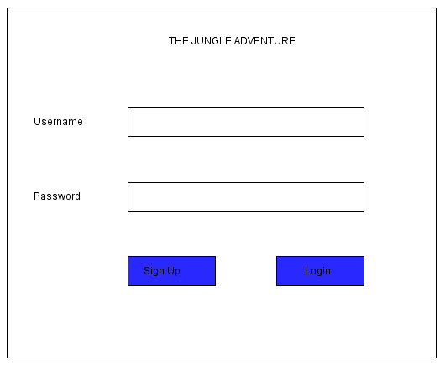

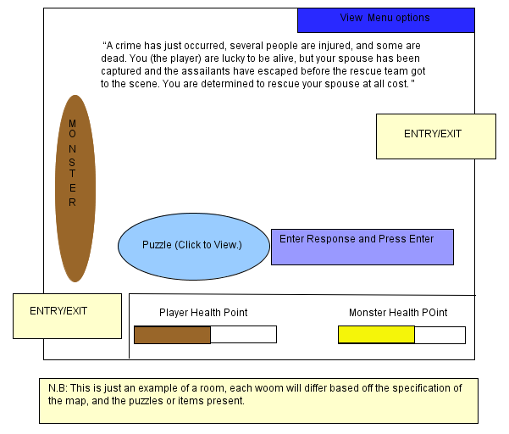

### Artifact Table

#### Use Case Diagram

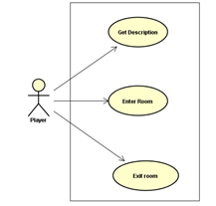

DEP: Dependency between this functional requirement and any other functional requirements (user the requirement ID to describe dependency)

Feature: Get description

DESC: The player must be able to see the description of the room they currently are in by using the command “Get Description”.

ID: FRRM 02

DESC: Enter Room

The player must be able to enter the room by choice

ID: FRRM 03

DESC: Exit Room

The player must be able to exit whenever s/he chooses to do so.

### Monster Features

#### Use Case Diagram

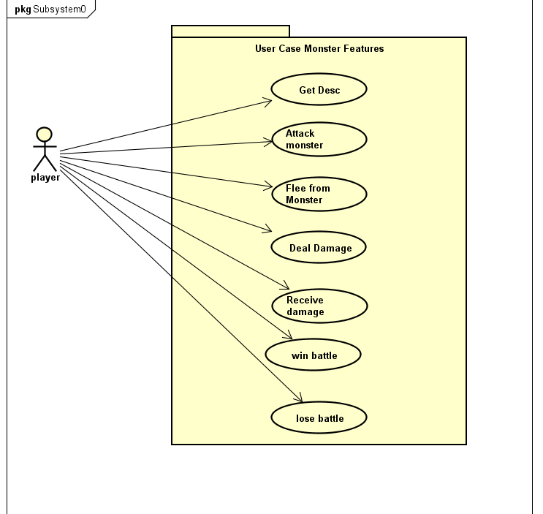

Win Battle

Lose Battle

#### Purpose

#### Associated Functional Requirements

##### Functional Requirement 1

ID: FRM 01

Feature: Get description

DESC: The player will try to get the information about the next monster within the room making sure they don’t walk into a trap or don’t come into the room without being prepared.

ID: FRM 02

DESC: Attack

Feature: Equipping the item to attack and block the monster attack within the battle to save health.

ID: FRM 03

DESC: Engage

Feature: Engaging the monster is by choice between the player don’t have to attack, the player can choose to take another path

ID: FRM 04

DESC: Flee

Feature: If the monster is to powerful the player has a chance to flee from the monster

### Puzzle Features

#### Use Case Diagram

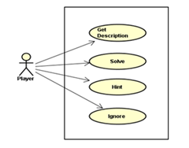Give additional note about failing the puzzle..IF Else

#### Purpose

#### Associated Functional Requirements

##### Functional Requirement 1

ID: FRP01

DESC: Get Description

Feature: The player must be able to get room description of puzzle.

ID: FRP02

DESC: Solve Puzzle

Feature: The player must be able to solve the puzzle.

If the player solves the puzzle correctly he/she will get all the points allocated.

Else the player may choose to ignore the puzzle or ask for a hint.

ID: FRP03

DESC: Hint

Feature: The player must be able to get a hint.

If the player chooses to use a hint, he/she will get half the points they would have gotten by solving the puzzle.

ID: FRP04

DESC: Ignore Puzzle

Feature: The player must be able to ignore the puzzle.

If the player chooses to ignore the puzzle he/she will not get any points.

### Artifact Features

### Inventory Features

Repeat subsections at this level and below for each feature.

#### Use Case Diagram

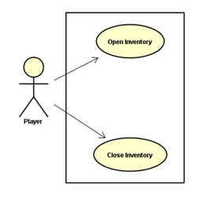

#### Purpose

#### Associated Functional Requirements

##### Functional Requirement 1

ID: FRIN 01

Feature: Open inventory

The player must be able to open the inventory pack

If player chooses to open, a list of all items relevant to the room is shown.

ID: FRIN 02

DESC: Close Inventory

The player must be able to close the inventory pack

If player chooses to open, a list of all items relevant to the room is shown.

### Item Features

#### Use Case Diagram

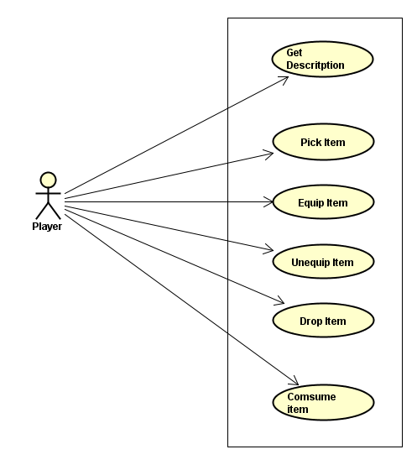

#### Buy Sell Trade

#### Purpose

#### Associated Functional Requirements

##### Functional Requirement 1

ID: FRIT 01

DESC: Get description

The player can read the description of all items they come across

ID: FRIT 02

DESC: Select / Pick up

The player can pick up the item and the item automatically goes to the inventory.

ID: FRIT 03

DESC: Drop

The player can drop items he or she does not find necessary or obsolete.

ID: FRIT 04

DESC: Equip

The player can choose to equip items they come across and items that are in the inventory.

ID: FRIT 05

DESC: Unequip

The player can choose to unequip items and the items automatically go to the inventory.

ID: FRIT 05

DESC: Consume

The Player can choose to consume items that are consumable

### Command Menu

Use Case Diagram

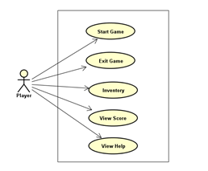

#### Open inventory

Close inventory

View points

View health

#### Purpose

#### Associated Functional Requirements

##### Functional Requirement 1

ID: FRM01

DESC: Start Game

Feature: The player must be able to start game.

ID: FRM02

DESC: Exit Game

Feature: The player must be able to exit game.

ID: FRM03

DESC: Inventory

The player must be able to access inventory.

ID: FRM04

DESC: View Score

The player must be able to view score

ID: FRM05

DESC: View Help

The player must be able to view help if needed.

## Software System Attributes

### Reliability

1. The system should never crash or hang, other than as the result of an operating system error
2. In case of any system failure, System shall display an error message in the main screen to inform user about possible problem.

### Availability

1. The system shall meet or exceed 99.99% uptime.
2. The system shall not be unavailable more than 1 hour per 1000 hours
3. Less than 20 seconds shall be needed to restart the system after a failure 95% of the time.

### Usability

1. The product should be easy to use by users who can read (age 7 to 80) who can only have one hand free.
2. 96% of the users will be able to complete representative tasks without requiring assistance.
3. The maximum number of clicks for any function in the system should not exceed five clicks.
4. The average response time between click and reaction must be less than 0.5 seconds. The maximum response time between click and reaction must be two seconds.

## Other Requirements